Muhammad Daniyal Qureshi

BSCS_VII-A

021-18-0009

Medicine MANGEMENT APP in FLUTTER

Flutter Assignment

Contents

**App Development** 1

**Frontend** 1

**Backend** 1

Sign In 2

Sign up 3

Home 4

Medicine List 5

Medicine Details 6

Drawer: 7

Cart: 8

**Testing** 9

**App recording and Source Code Link:** 11

# **App Development**

**Frontend :** Flutter Material Widgets (Stack, Card Widgets, ,Carousel Widget,Drawer, Elevated Buttons, DropDownButton, AwesomeAlertDialog,FutureBuilder).

**Backend** **:**Firebase ,SharedPrefereces

## Sign In

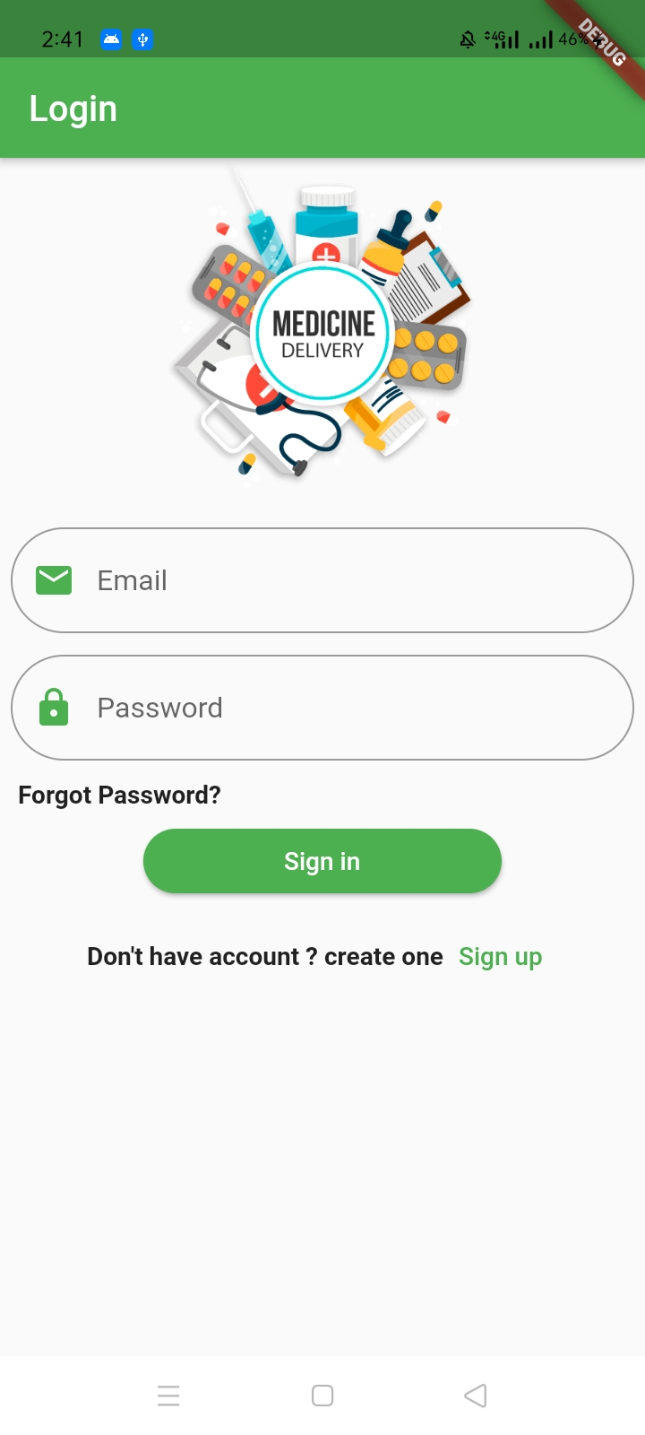

## Sign up

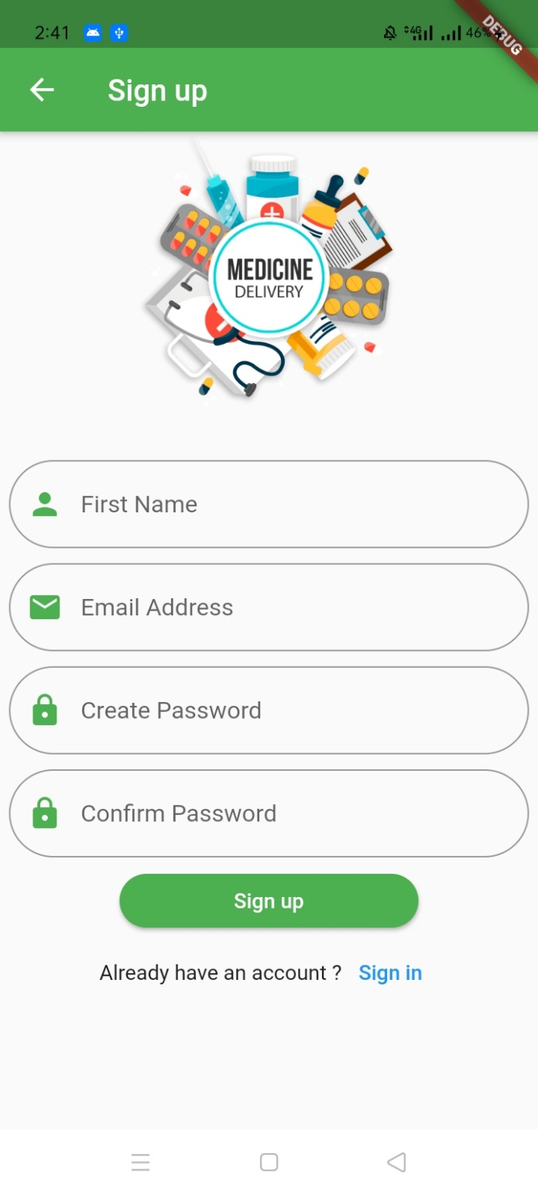

## Home

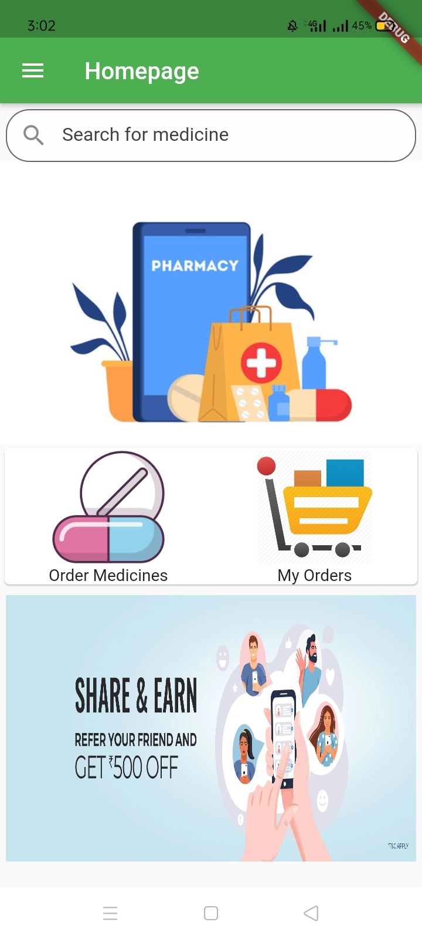

## Medicine List

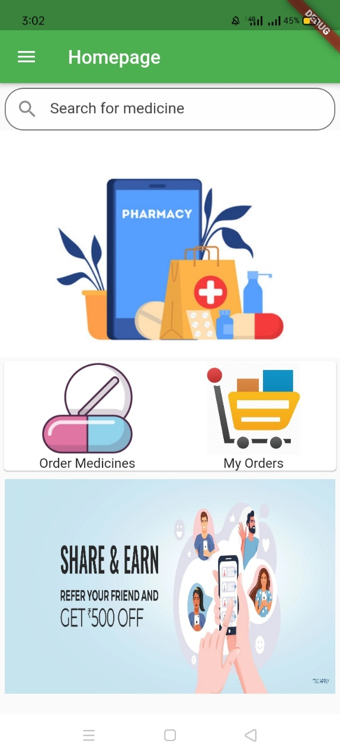

## Medicine Details

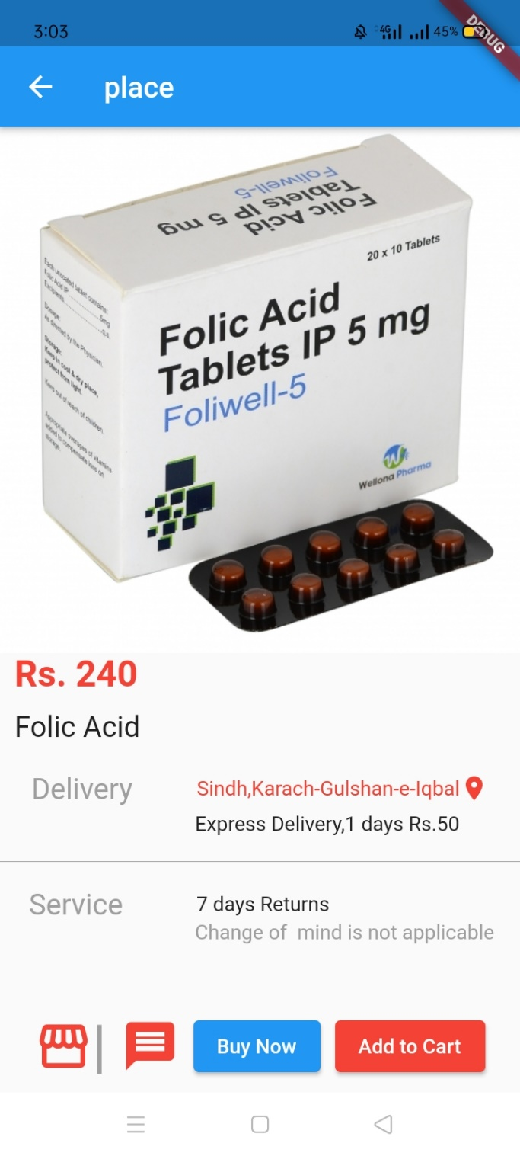

## Drawer:

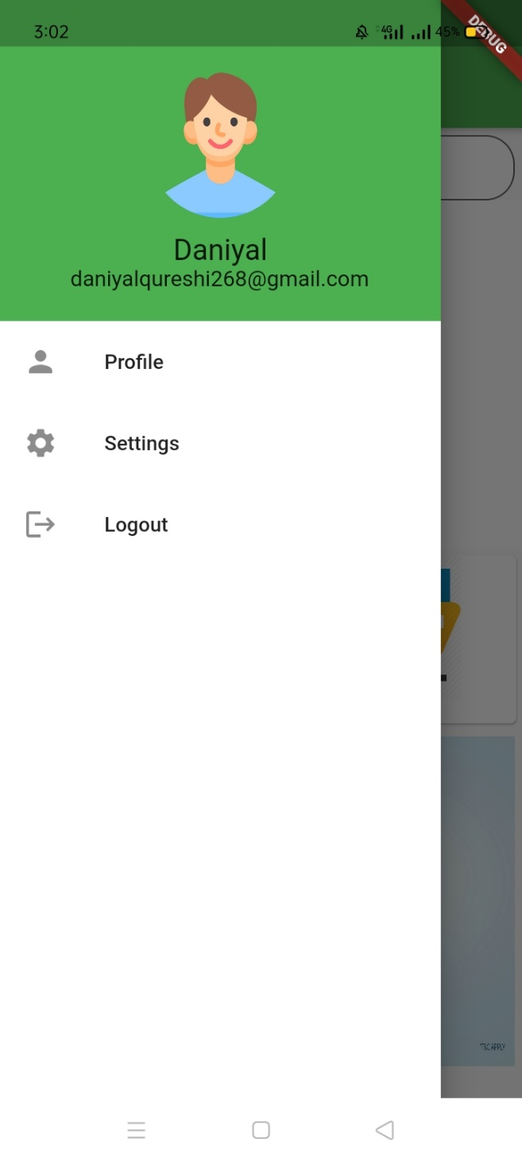

## Cart:

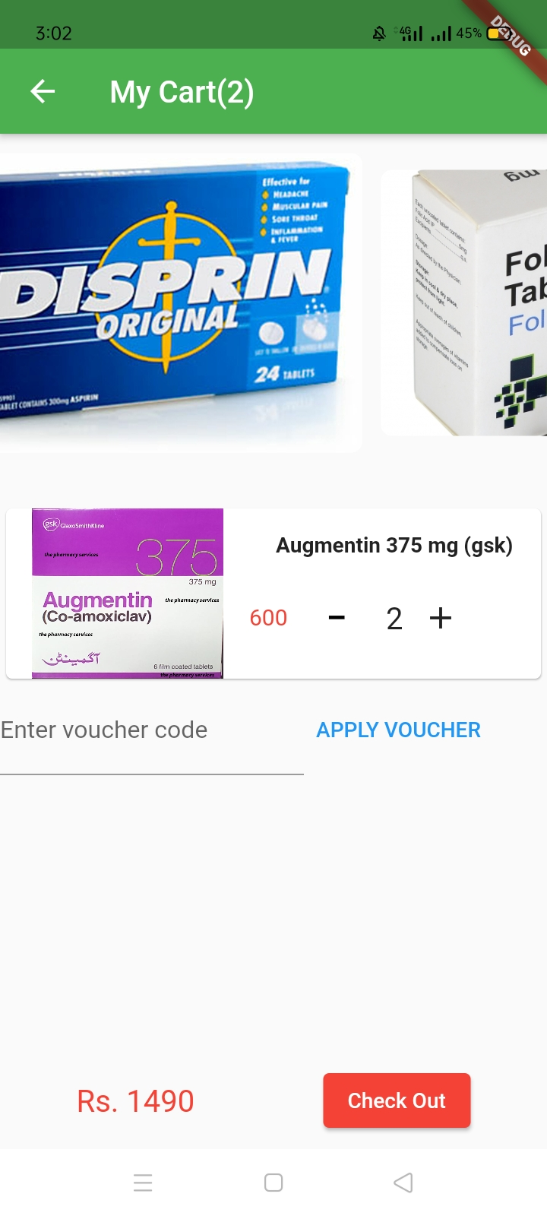

# **Testing**

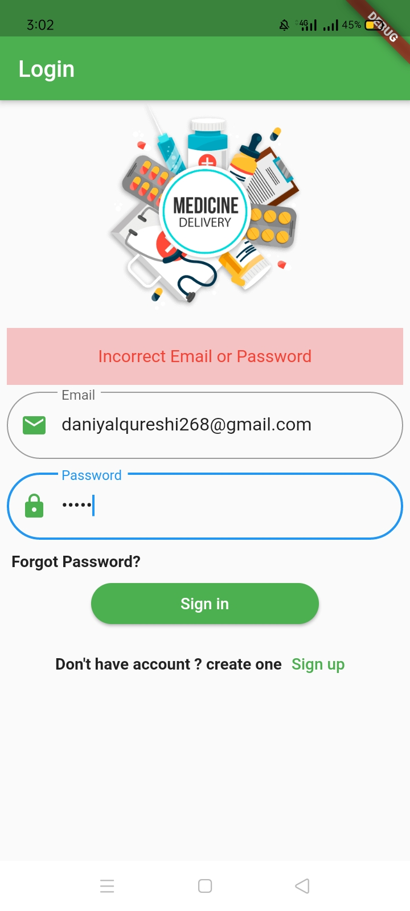

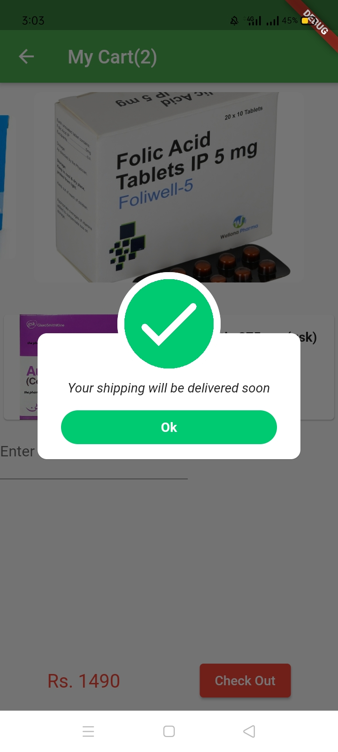

# **App recording and Source Code Link:**

<https://drive.google.com/drive/folders/1JxQKUjgk-1YCsjGIkkUaOQQgFDVJgDVh?usp=sharing>